Task : create advertisement

- Copy all text.
- Design it with different Fonts, Colors and Picture!!!
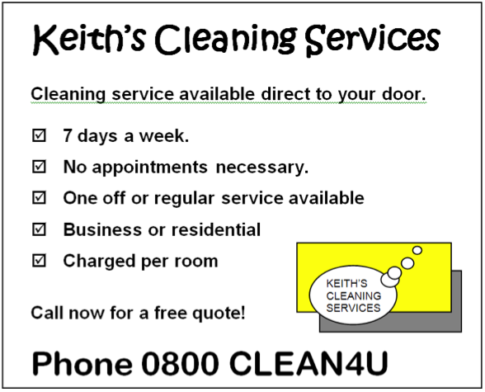

Task : create advertisement

- Copy all text.
- Design it with different Fonts, Colors and Picture!!!

